Ideation Report Template

**Introduction**:

#### I need to create a portfolio

* It can be a physical book or binder that organizes samples of my work, or an online portfolio with electronic files.
* Portfolios are a great way to demonstrate the competencies I would list on a resume or talk about in an interview.
* Outside of a job or client search, archiving samples of my work to a portfolio is a great way to keep track of my accomplishments.

### User Interface Design and Prototype:

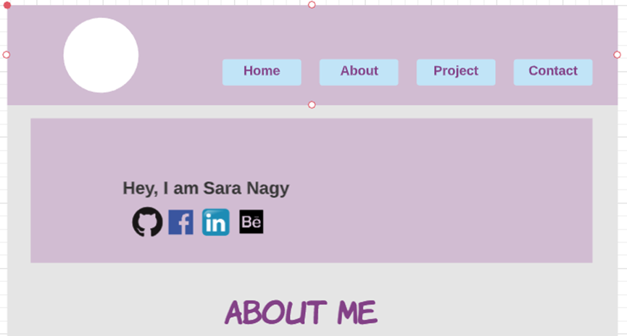

### 

### 

### References:

* <https://www.shopify.co.uk/partners/blog/web-design-portfolio-inspiration>
* <https://www.mockplus.com/blog/post/web-design-portfolio>

**Thank you for your time**.